CHAPTER 1

Title

A.Author¹*, B.Author²
¹Affiliations
Email (indicate corresponding authors with a *)

Abstract
The abstract should be short and approx. 100 words. It can be based on key sentences from the Introduction.
Keywords
Please list 5 or more keywords describing your chapter.
Contents
A table of contents will be included here by the publisher during final typesetting.

1. Introduction
The entire manuscript must be in English. Please use the Time New Roman font with 13 font size.
Please make sure you signed a copyright license agreement. We will need this to be able to publish your article/book.
For easy formatting you can use the MRF chapter styles such as: MRF Text, MRF Section Heading, MRF Subsection Headings, MRF Captions, MRF Equations, etc. These are located in the Quick Style Gallery.
Use italic for emphasizing a word or phrase. Please do not use boldface typing or capital letters within the text.

2. Organization of the Text

2.1 Figures
Figures (refer with: Fig. 1, Fig. 2, ...) should be presented as part of the text, leaving enough space so that the caption will not be confused with the text. The caption should be self-contained and placed below or beside the figure. Generally, only original drawings or photographic reproductions are acceptable. Only very good photocopies are acceptable. Utmost care must be taken to insert the figures in correct alignment with the text. Half-tone pictures should be in the form of glossy prints. If possible, please include your figures as graphic images in the electronic version. For best quality the pictures should have a resolution of 300 dpi (dots per inch).
Color figures are welcome for both online and print version.

2.2 Section Headings
The section headings and second level headings are in boldface capital and lowercase letters.

2.3 Page Numbers
Do not number your paper

2.4 Tables
Tables (refer with: Table 1, Table 2, ...) should be presented as part of the text, but in such a way as to avoid confusion with the text. A descriptive title should be placed above each table. Units in tables should be given in square brackets [meV]. If square brackets are not available, use curly {meV} or standard brackets (meV).

2.5 Special Signs
for example: α γ μ Ω () ≥ ± ● Γ {110} should always be written in with the fonts Times New Roman or Arial.

2.6 Macros
Do not use any macros for the figures and tables.

2.7 Equations
Equations (refer with: Eq. 1, Eq. 2, ...) have to be numbered sequentially, and the number put in parentheses at the right-hand edge of the text. The use of Microsoft Equation is fine.
c² = a² + b² (1)

3. Literature References
References are cited in the text just by square brackets [1]. Two or more references at a time may be put in one set of brackets [3,4]. The references are to be numbered in the order in which they are cited in the text and are to be listed at the end of the contribution under a heading References, see our example below.

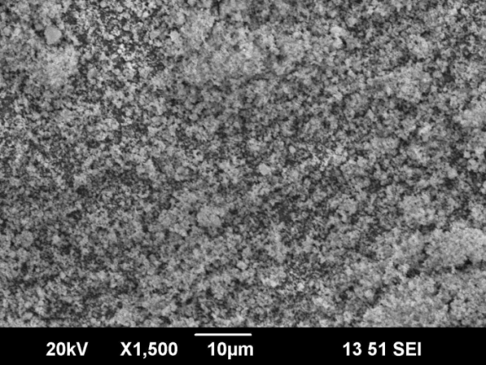
Figure 1. Please use good resolution figures when possible. 300 dpi resolution figures are preferred. Please feel free to use colour for your figures. Both print and online version will be reproduced in full colour.
Table 1. Sample table
Parameters | Values
a (Å) | 5.5563(10)
b (Å) | 7.8209(12)
c (Å) | 5.5150(10)
α=β=γ (º) | 90
Volume (Å³) | 239.66 (11)
Density (gm/cc) | 6.70(1)

References
[1] A Praemer, S. Furner, D. P. Rice: Musculoskeletal conditions in the United States (American academy of orthopaedic surgeons, Rosemont 1999).
[2] Author's/Editor's Last name, initials (if a person; if not, list organization), Year. Title. (Edition). Place of publication: Publisher (if ascertainable). Retrieved from: URL
[3] J. van der Geer, J.A.J. Hanraads, R.A. Lupton, The art of writing a scientific article, J. Sci. Commun. 163 (2000) 51-59.
[4] W. Strunk Jr., E.B. White, The Elements of Style, third ed., Macmillan, New York, 1979.
Reference to a chapter in an edited book:
[5] G.R. Mettam, L.B. Adams, How to prepare an electronic version of your article, in: B.S. Jones, R.Z. Smith (Eds.), Introduction to the Electronic Age, E-Publishing Inc., New York, 1999, pp. 281-304.
[6] R.J. Ong, J.T. Dawley and P.G. Clem: submitted to Journal of Materials Research (2003)
[7] P.G. Clem, M. Rodriguez, J.A. Voigt and C.S. Ashley, U.S. Patent 6,231,666. (2001)
[8] Information on http://www.weld.labs.gov.cn

